

School of Computers and Information Engineering Spring semester 2020

Internet Programming Project Report

MIRACLE ACADEMY

Team members: ID: U1610011 Abduvokhid Abduvokhidov

ID: U1610238 Sultonbek Bokijonov

LINK TO GITHUB: https://github.com/iuthub/ip-group-project-miracle.git

LINK TO WEB SITE: http://miracleacademy.uz/

Front-end developer: Sultonbek

Back-end Developer: Abduvokhid

Description: You can access to our site by using mobile phone and desktop. This site is about the information of education center which is named Miracle Academy in Uzbekistan. There are different kinds of classes: English Lessons for Beginners, Web Programming Classes and so forth. In order to participate these classes, users give information such as name and phone number. There are also a lot of photos about lessons. It is information why you should choose this education center.

Also, users can give their mail to know latest news about this education center day to day, so they can see last news on the news section of this site. In the next section, you can give feedbacks about lessons and your invitations of ideas for The Miracle Academy Education Center by writing name, email and texts. On bottom of site, you can get information comments of our pupils and connecting with different links.

Details: we have used HTML, CSS, JAVASCRIPT, PHP, YII2 instead of laravel, bootstrap to solve technical issues I have used StackOverflow, StackExchange, CodePen, jsFiddle, Github, etc.

We store all user input collected via forms in a database deployed to a MySQL server. 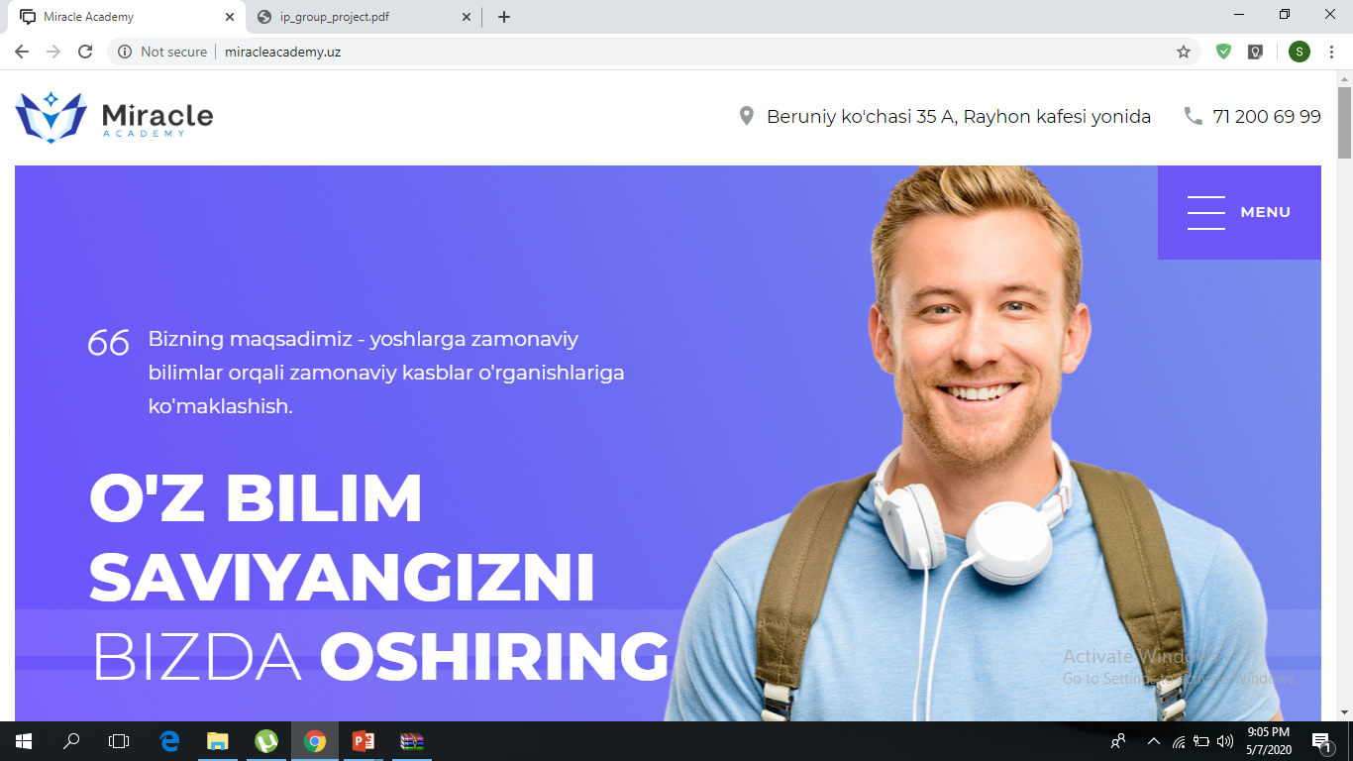

Main page is included company name and information about it.

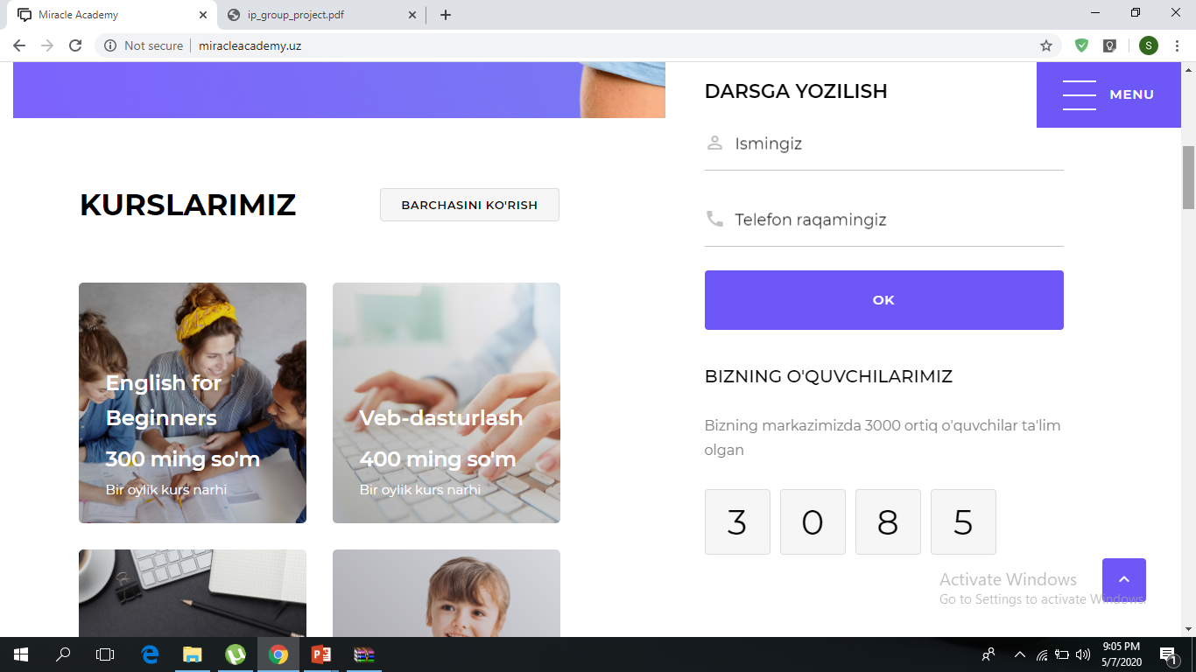

This is Information about classes.

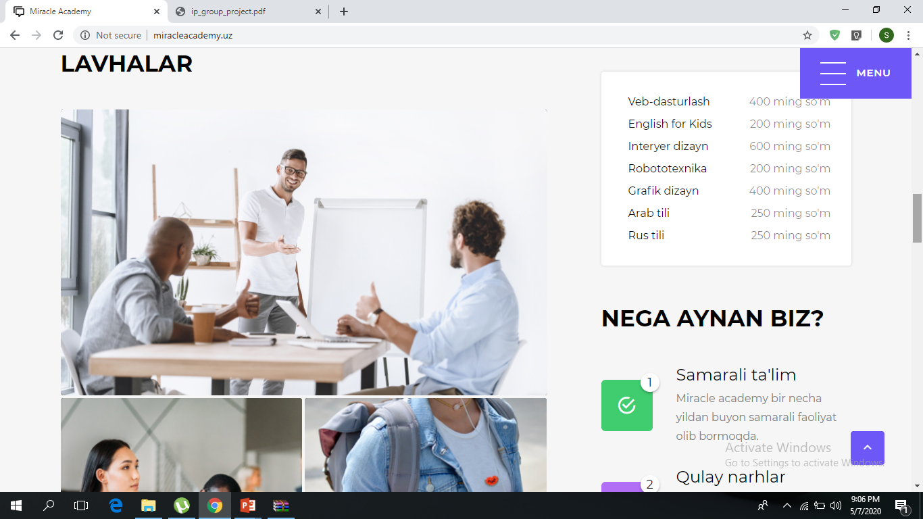

These are photos during lessons.

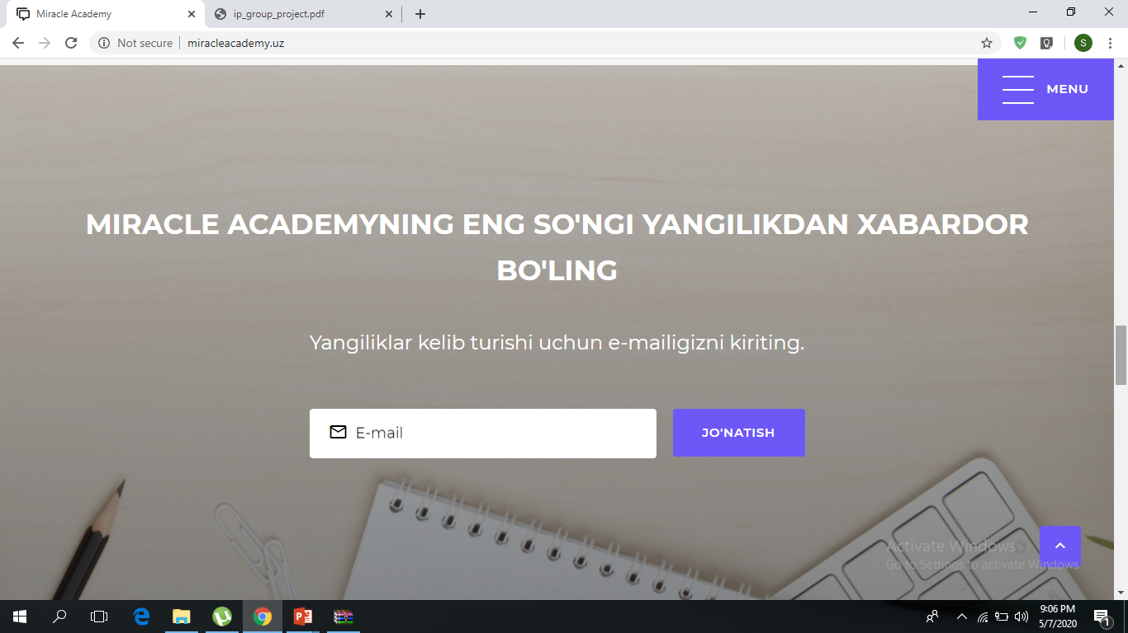

This is filling to get last news section.

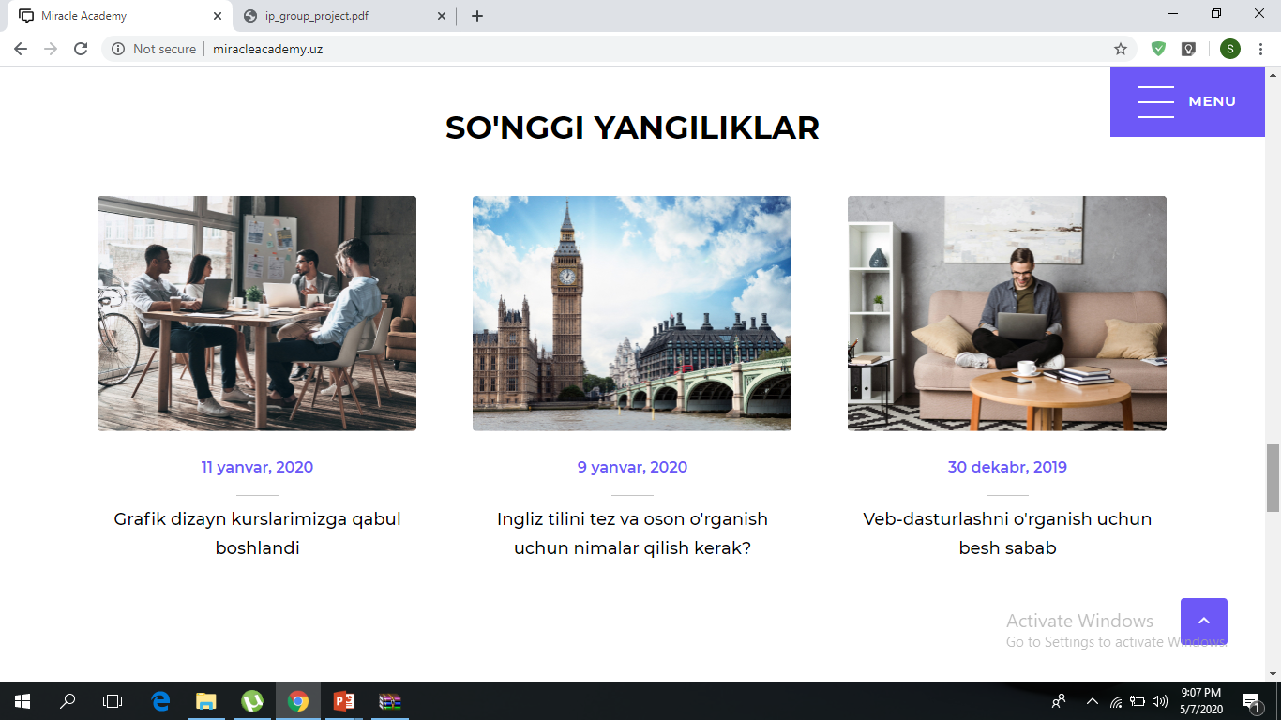

Latest news section of Miracle Academy Education Center

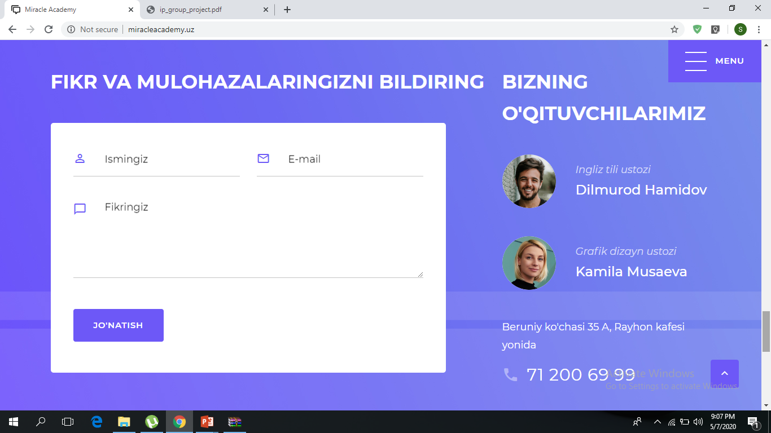

Information about teachers

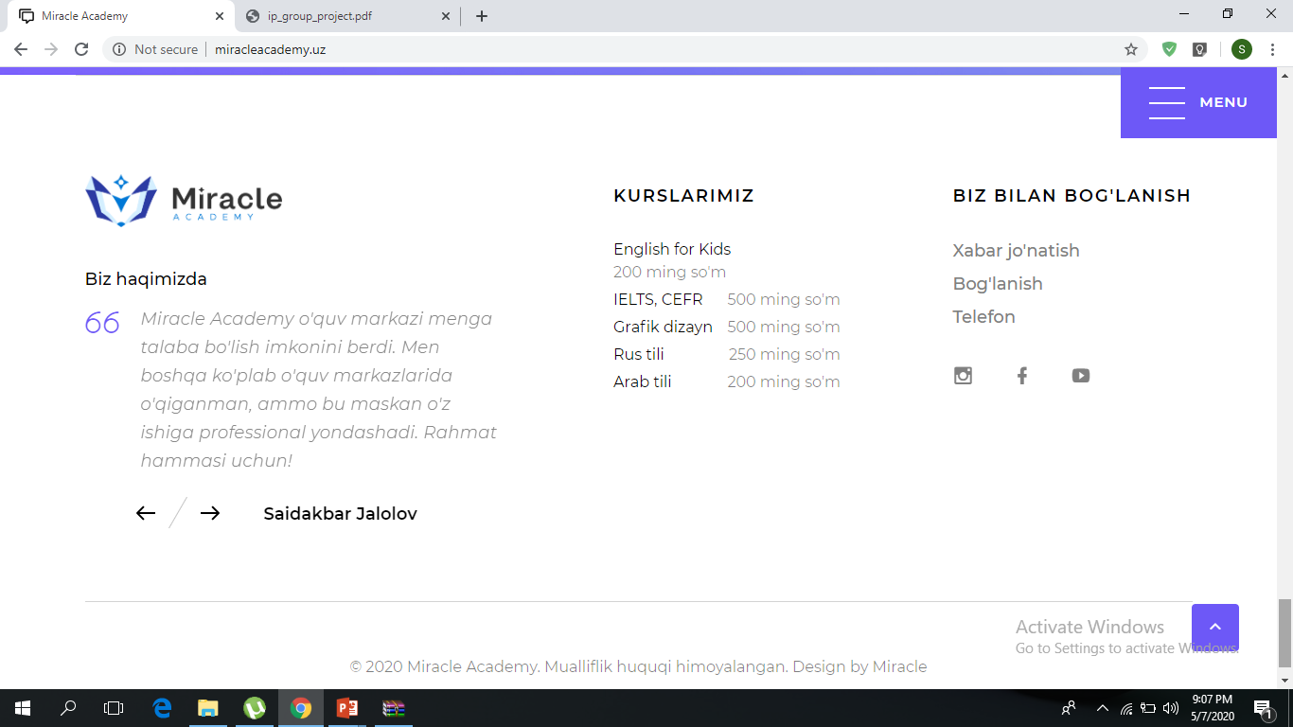

Comments and connection section with education center